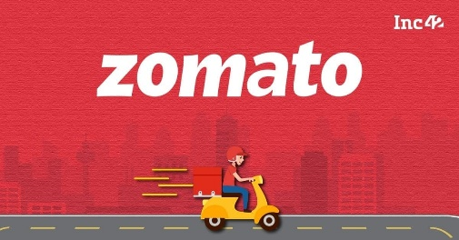

Restaurant Demographics & Presence
- Which cities have the most restaurants listed on Zomato? 🏙️
- What is the distribution of restaurants across different localities within a major city (e.g., New Delhi, Mumbai)?
- Are there any countries where Zomato has a particularly strong or weak presence based on the number of restaurants?

Cuisine Popularity & Availability
- What are the top 10 most popular cuisines offered across all restaurants in the dataset? 🍜
- Is there a correlation between cuisine type and average cost for two people?
- Which cuisines are predominantly offered by restaurants that also offer online delivery?

Cost & Dining Trends
- What is the average cost for two people across all restaurants? 💰
- How does the average cost for two vary by city or country?
- What percentage of restaurants offer table booking versus online delivery?

Ratings & Reviews Insights
- What is the average aggregate rating for all restaurants? ⭐
- How does the average rating differ between restaurants that offer online delivery and those that don't?
- Are there specific cuisines that tend to have higher aggregate ratings?
- Is there a relationship between the number of votes and the aggregate rating?

Location-Based Analysis
- Are there particular localities that have a higher concentration of highly-rated restaurants?

Currency & Price Range Analysis
- Which currencies are most commonly used across the restaurants in the dataset?
- What is the average cost for two for each price range?

Delivery & Takeaway Analysis
- What percentage of restaurants offer switch to order menu?
- How does the price range differ for restaurants that offer online delivery versus those that don't?

